Including animal welfare and use of antibiotics in diet assessments to highlight trade-offs with environmental impact
Rydhmer, L.¹, Röös, E.²
¹Department of Animal Biosciences, Swedish University of Agricultural Sciences
²Department of Energy and Technology, Swedish University of Agricultural Sciences, Box 7013, 750 07 Uppsala, Sweden
Abstract:
XXX
Keywords: XX
Highlights:
- XX
- XX
- XX
- XX
Journals:
- Sustainable Production and Consumption
- Journal of Cleaner Production
- Science, Environment and Policy

1. Introduction
Modelling diets’ impact on humans, animals and nature, can give politicians and consumers a scientific base for decisions concerning food choices. Commonly, such diet assessments are performed by multiplying the amount of certain foods or commodities in the diet with the per kg impact of each food or commodity as measured by a set of indicators. Thereafter the impact of all foods is summed up resulting in a total impact of the diet. So far, diet assessments typically include the diet’s impact on the environment, using indicators such as the carbon, water and land footprint (Harrison et al., 2022) and on health by e.g. assessing how a set of diet related risk factors (e.g. high consumption of red meat) are likely to affect mortality and disease burden (Springman et al., 2020).
The interest in sustainability assessments covering more than environmental and health is growing (Lanzoni et al., 2023). Social sustainability aspects of consumption cover, for example the diet’s impact on health and wellbeing going beyond the human health impacts of ingesting different types of foods, including food productions’ contribution to antibiotic resistance.
Antimicrobials are used to cure and to prevent infections in humans and animals, and in some countries also for animal growth promotion. All use of antimicrobials increases the risk of microbes developing resistance to antimicrobials. Antimicrobial resistance occurs naturally but develops faster when antimicrobial pharmaceuticals are used. EU’s Farm to Fork strategy (EU Commission, 2020) states that antimicrobial resistance is linked to excessive and inappropriate use of antimicrobials in animal and human healthcare. The EU commission therefore takes actions to reduce overall EU sales of antimicrobials for farmed animals and in aquaculture (EU Commission, 2020), but a greater volume of antimicrobials is still sold to treat disease in food-producing animals than in humans (European Environment Agency, 2024). The fight against antimicrobial resistance is closely linked to SDG3 Good health and well-being and SDG 12 Responsible consumption and production (WHO, 2020). A review made by a large international group of ‘Antimicrobial Resistance Collaborators’ showed that 1.27 million deaths in the world were directly caused by antibiotic resistant bacteria in 2019. The number of deaths associated with antibiotic resistance was almost four times higher (Antimicrobial Resistance Collaborators, 2022). In Europe (WHO European region; 53 countries), 541,000 deaths were associated with antibiotic resistance and the main reasons were blodstream, intra-abdominal and respiratory infections (European Antimicrobial Resistance Collaborators, 2022). The most common bacteria were Escherichia coli and Staphylococcus aureus. Methicillin-resistant S aureus and aminopenicillin-resistant E coli were dominating common bacteria-drug combinations.
Since food production causes harm to animals directly and indirectly (Hampton et al., 2021), animal health and welfare aspects can be considered an important part of sustainability (Keeling, 2005; Vinnari & Vinnari, 2022) and hence be part of diet assessments. The World Organisation for Animal Health has defined animal welfare as “the physical and mental state of an animal in relation to the conditions in which it lives and dies” (WOAH, 2022). The concept ‘animal welfare’ is not mentioned in UN’s sustainable development goals (SDG) but changes leading to improved animal welfare are compatible with fulfilment of the SDG (Keeling et al., 2019). Current norms concerning animal welfare are reflected in the EU animal welfare law (Council directive, 1998), although, 84% of the respondents in the Eurobarometer survey (2023) believe that the welfare of farmed animals should be better protected than it is now. There are also national laws and standards in place, which vary in ambition across European countries and production systems. There are also organisations focusing on ‘animal friendly’ production systems and such food products are marketed with specific labels referring to specific standards such as outdoor access and these standards can be certified by an independent organisation, or not.
According to EU’s Farm to Fork Strategy (2020) “Better animal welfare improves animal health and food quality, reduces the need for medication and can help preserve biodiversity”. A resolution adopted by the UN Environment Assembly (2022) acknowledges that animal welfare can contribute to addressing environmental challenges and that “health and welfare of animals, sustainable development and the environment are connected to human health and well-being”. However, there are both synergies and goal conflicts between animal welfare, use of antibiotics and environmental impact (Bartlett et al., 2024). Higher stocking density, for example, can reduce climate impact but at the same time reduce animal welfare and increase infection pressure (ref). Exchanging beef from an extensive production system for pork and chicken meat from intensive production systems in a diet can reduce climate impact per kg meat, but may involve trade-offs with animal welfare and use of antibiotics. Therefore, it is important to include animal welfare and use of antibiotics together with environmental impacts in diet assessments.
Diets vary between regions both regarding the type of foods consumed (plant or animal sourced and species) and the origin of food ingredients (country and production system). We focus on European diets in this study. Most consumers in Europe eat animal products from several different species (e.g. pig, hen and honeybee). Furthermore, they eat animal products from several European countries (i.e. domestic and imported food). The import of animal sourced food from non-European countries is limited (Schwarzmueller & Kastner 2022). Preferably, assessments of animal welfare and use of antibiotics should be based on many indicators and on data from a large number of representative production units in all production systems contributing to the consumers’ diets. However, there are no open databases with potential indicators of animal welfare and use of antibiotics covering all species, countries and production systems relevant for assessment of European consumers’ diets. Official data on national use of antibiotics for animals in Europe exists (ESVAC, 2023), but the amount of antibiotics is not divided upon animal species. Thus, comparable data on use of antibiotics use per kg of animal product are lacking. Primary data could be collected from representative production sites, for example by collecting antibiotic prescriptions on farms. For animal welfare, data could be collected with the Welfare Quality® Assessment Protocols (ref) which is an established tool for pig, cattle and poultry. When the aim is to evaluate total consumption of all foods in a typical diet with different types of animal products, such large-scale field data collection is not feasible for practical and economic reasons. Instead, rough assessments of animal welfare and use of antibiotics have to be performed based on existing data from national databases, scientific studies and reports of agricultural organisations and authorities.
The aim of this study was to further develop methods for including animal welfare and use of antibiotics in diet assessments, as a complement to environmental indicators. To be useful in diet assessments, the impact should be expressed per functional unit, and we have chosen kg animal sourced food product as the functional unit. We propose a set of indices to capture animal welfare loss, based on number of animals needed to produce 1 kg of animal product, animal welfare level of production system and different species’ ability to perceive negative effects of being used by humans, and an index for the use of antibiotics based on amounts of antibiotics sold for animals and estimated distribution over animal species and total biomass of different species. We exemplify the use of these indices for current dietary patterns in three countries, and include an assessment of the climate impact of these dietary patterns to illustrate how the inclusion of animal welfare and antibiotics use indices enable the identification of important trade-offs when evaluating potential dietary changes.

2. Background

2.1 Animals in sustainability assessments
So far, the welfare of both farm animals and wild animals have been almost invisible in sustainability assessments (Vinnari & Vinnari, 2022), hidden behind terms like climate impact or biodiversity loss. Figure 1 shows how Vinnari & Vinnari (2022) include what they call ‘non-human animals’ in the definition of sustainability. Our indicators for climate impact and use of antibiotics are only used for food from farmed animals. The animal welfare indicator is used for food from both farmed and wild animals, covering the whole life for farmed animals and the catching or hunting and the killing for wild animals.

2.2 Ethics and animal sourced food
Animal rights and the extent to which using animals for food production can be morally justified is a complex issue that has been discussed extensively by philosophers. Fundamentally, two main perspectives exist; the utilitarian view which supports humans using other animals provided their interests are given the same consideration as human interests, and this use enhances overall wellbeing (Singer, 1975) and the animal rights perspective, considering any use, abuse or killing of sentient animals morally wrong and should therefore be heavily decreased or abolished (Regan 1985). Vinnari & Vinnari (2022) presents a framework reflecting these perspectives and describing a potential shift from no rights for animals via simple rights to fundamental right for animals. Our work here fits within ‘simple rights’ on their scale, meaning that human use of animals is acceptable “but subject to welfare considerations” and “suffering inflicted on animals should be minimized”. From a utilitarian point of view, an individual animals’ impaired welfare may be outweighed by other factors beneficial for humans, such as lower climate impact of animal production (Ref Sandöe). If a large number of animals severely suffer in food production, the beneficial impact on humans of that food must be large to outweigh the suffering of animals. Ideally, consideration should not be limited to the production animals themselves, but should include all animals in the system, e.g. parents of production animals and wild animals affected by e.g. feed production (Vinnari & Vinnari, 2022).
From an animal rights perspective (a version of duty ethics), the animal is a sentient being and an individual worthy of respect in its own right. The animal should not be regarded as a mere instrument for human purposes (Regan, 1983; Francione, 2010). This view excludes all consumption of food sourced from animals’ having cognitive abilities and animal welfare indicators then becomes obsolete. Although our animal welfare indicators are developed with an underlying assumption that humans’ have the right to use and kill animals for food production, the animal rights view is included as the indicator considers the number of animals used by humans. The animal integrity perspective calls for a sense of respect for the animal as a sentient being experiencing its own life and existing on its own premises; the animal is not defined through its function for humans (Röcklinsberg et al., 2014). According to Rutgers and Heeger (1999), animal integrity describes the “wholeness and intactness of the animal”. With this overall respect for other beings, the ethically acceptable use of animals cannot be based on utilitarian calculations only; number of killed animals needed for a diet matters even if these animals have a good welfare. How important number of animal lives is in a diet assessment cannot be answered by scientific facts since it depends on personal set of values, choice of ethical theory and worldview.

2.3 Animal welfare challenges
There are several major animal welfare issues in animal production, often related to frequent diseases and injuries and restricted area available for the animals (ref). Death is not an animal welfare issue in itself but mortality on farm is often preceded by a period of disease or stress and thus low welfare. Animals’ ability to perform behaviours that they are strongly motivated to perform is crucial for animal welfare (ref). In intensive production systems animals are often kept in an environment where there is not enough room for performing those behaviours, such as rooting or grazing. High stocking density does not only hinder animals’ movements - it also increases the risk of aggressive interactions and spreading of infections in the group (ref).
Animals like salmon, pigs and chickens are raised to be slaughtered at a given time, usually before sexual maturity. Lying hens and dairy cows producing eggs and milk are slaughtered as adults. Wild animals are killed during hunting or fishing. The whole slaughter process, from animal collection to death, may cause fear and pain. The duration of this process varies between production systems, with a range from less than an hour to more than a day (ref EU transport?).
Domesticated animals are selected for high production levels (growth, milk, eggs etc). This has led to a more effective food production with lower climate impact per kg product (ref) but also some unfavourable genetic changes in traits important for animal welfare. Two well-known examples are high selection pressure on milk yield that increases the risk of mastitis (udder inflammation) and high selection pressure on growth rate that increases the risk of leg problems (Rauw et al., 1998). Therefore, resistance to mastitis and strong legs and other traits important for animal welfare are included in the breeding goals alongside with the production traits. However, considerable problems still prevail.

2.3 Assessing animal welfare per kg of product
Zira et al. (2021) included animal welfare in a life cycle sustainability assessment (LCSA) of different pig production systems using X indicators especially relevant for pig production, e.g. X and Y. For diet assessments, a method that can be used across different animal species (e.g. beef, chicken, blue mussels), accounting also for different species cognitive ability, is needed. Scherer et al. (2018) developed a framework for integrating animal welfare in LCSA across species. They propose three different indicators: animal life years suffered (ALYS), loss of animal lives (AL), and loss of morally adjusted animal lives (MAL). ALYS is calculated by multiplying the number of affected animals per kg of product with the sum of the ‘life quality’ adjusted life duration and the slaughter duration. This means that a shorter life will be preferable, as it will end suffering. AL on the other hand, add the ‘lives lost’ to the ALYS, life lost being the number of affected animals per kg of meat times the duration of life that the animal did not live due to premature death. AL is similar to disability-adjusted life years (DALYs) often used to evaluate impacts on human health. AL thus assumes that all animals have an interest in staying alive but values all animal lives equally regardless of species. MAL takes animals’ moral value (denoting “intelligence and self-awareness” of different species) into account using brain mass, number of total neurons or number of corticol neurons (depending on data availability) to determine the moral value (Scherer et al., 2018). Paris et al. (2022) who studied three Western diets with the animal welfare indicators from Scherer et al. (2018) used brain to body weight ratio for the species where they did not find data on number of neurons. MAL is calculated as the number of animals affected times life lost times the moral value.
We were inspired by the work of Scherer et al. (2018) but wanted another way to describe different species’ ability to perceive negative effects of being used for food production, for several reasons. Firstly, although Herculano-Houzel (2012) use neuron numbers to predict animals’ ‘intelligence’, the correlation to “the physical and mental state of an animal” (in the animal welfare definition of WOAH) seems unclear. Secondly, data on number of neurons are not available for all species involved in European diets. Furthermore, we wanted to take the potential effects of age (e.g. a newly hatched chicken compared to an adult hen) and domestication into account. Although the number of scientific studies on animals’ ability to feel pain, fear and distress is increasing (ref, ref) comparable data for all species included in European diets are still lacking. While waiting for such data, we defined animals’ ability to perceive negative effects of being used by humans with a questionnaire to animal scientists.
In addition, we wanted to introduce an addition index which takes the number of animals affected into account, the cognitive ability of animals, and the quality of life, but that disregards both the lifetime of the animal and the life duration lost by premature death. ALYS takes life duration into account, assuming that every day is a day suffered, e.g. a calf slaughtered at 6 months will have a better ALYS value than a calf slaughtered at 12 months if both calves are raised in the same environment. However, animals can experience both positive and negative emotions during life (although our indicator only describes negative animal welfare aspects) and shorter life duration might not be preferable from an animal welfare perspective. However, in contrast to the AL, in this index we did not want to include the lifetime lost to premature death to reflect the perspective that if we accept that humans have the right to use and kill animals for food production, the lost lifetime has little relevance for our animal welfare indicator, e.g. for the calf slaughtered at 6 months, these 6 months is its full life and if the environment is bad it has suffered during its whole live. For these reasons we wanted to construct an index that is agnostic to the lifetime and lifetime lost.
In addition to the cognitive ability of animals, the type of environment and management in which the animals are kept leading to mortality, disease and impaired ability to perform natural behaviours (we call this animal ‘suffering’) determine animal welfare. Scherer et al. (2018) calls this ‘life quality’ and uses only one aspect to capture this. The aspect differs between species, e.g. days on pasture for dairy cattle and stocking density for chickens. We wanted a broader but still feasible (in terms of data collection and comprehensiveness) description and used disease frequency, mortality on farm, lack of space and duration of slaughter process to describe the production system to describe “the conditions in which it [the animal] lives and dies” as stated by WOAH (2022).
Similar to Scherer et al. (2018) we took the number of involved animals needed to produce a certain amount of animal product (e.g. 1 kg of beef) into account but adjusted the number for very small animals (the size of a shrimp and smaller) and for animals with a very high production (dairy cows). Without such adjustments, the animal welfare index value for the smallest animals would be very unfavourable even if the production system was perfect and the indicator value for the dairy cow would be very favourable even if the production system was the worst possible.

2.4 Challenges in the use of antibiotics
Antibiotics is a group of antimicrobials produced from moulds or made synthetically and used against bacteria. The aim of treating humans and animals with antibiotics is to kill bacteria or prevent bacteria from multiplication. Antibiotics are needed in both human and veterinary medicine to cure infections and to prevent infections when surgery and cancer treatments are performed. The largest share of antibiotics sold worldwide is aimed for animals used for production of animal-sourced food (ref). Food products from animals treated with antibiotics do not cause direct health problems among consumers – use of antibiotics in food production is a social sustainability aspect because it increases resistance to antibiotics and that threatens the health and welfare of humans and animals. The development of resistant bacteria takes place in humans and animals and in the environment, e.g. in manure (ref). In general, the problems with antibiotic resistance get worse the more antibiotics that are used.
A completely antibiotic-free production of animal-sourced food is not acceptable from an animal welfare perspective since sick animals shall be treated. The goal is a prudent, medically rational use of antibiotics so that specific antibiotics continue to offer successful treatments against specific infections in humans and animals, and so that the ratio of resistant bacteria species does not further increase. Unlike animals, bacteria have the capacity to exchange genetic material between each other within generation. When, for example, manure is used as fertilizer on the field, bacteria that have achieved resistance due to mutations can transfer the resistance genes to other species of bacteria in the soil (ref). The magnitude of this transfer is, however, at large unknown.
Antibiotics has been used in food production for three reasons:
- To cure infected animals
- To prevent animals from being infected
- To promote higher production levels (often higher growth rate), so called ‘growth-promotors’
Regular use of antibiotics by routine for prevention and as growth-promotors can mask issues related to hygiene, stocking density and bad management. Thus there is a strong association between the indicators for animal welfare and use of antibiotics. The use of antibiotics as growth promotors is however prohibited in the EU since 2006 (ref) and the use of antibiotics for regular disease prevention is prohibited in the EU since January 2022 (ref).
The actual amount of antibiotics used for animals in food production is not known and therefore the country-wise monitoring performed by European Surveillance of Veterinary Antimicrobial Consumption (ESVAC) is based on sold amounts. Since the population of animals varies between countries the use of antibiotics is reported per total biomass. Corresponding data are available for some countries outside Europe and missing for others. So far, only a few countries report data on sales per species and no country reports data on sales per production system in a systematic way.
Treatments days can be a more accurate indicator of risk of resistance than mg active substance/tonne biomass. Läs på, vad är vitsen? We choose mg active substance/tonne biomass because the data are official, and available for all European countries.

3. Method and data

3.1 Animal welfare indices
The animal welfare indices are expressed per kg of raw commodity, e.g. kg of meat (bonefree), kg of egg or kg of milk. The animal welfare indices consider 1) the number of involved animals to produce 1 kg of raw commodity, 2) these animals’ ability to perceive negative effects of being used by humans, and 3) a judgement of the suffering that animals are exposed to in the typical production system.
We present results for three indices: 1) a new index, Perception Adjusted Animal Lives Affected (PAALA), 2) ALYS as defined by Scherer et al. (2018) but with an extended ‘life quality’ component here called ‘suffering’, and 3) Perception Adjusted ALYS (PAALYS), calculated as follows:
PAALA = number affected x ability x suffering (incl. slaughtering) x 100
ALYS = number affected x ((life duration – slaughtering duration) x suffering (excl. slaughtering + slaughtering duration)
PAALYS = ability x ALYS

The animal welfare index value for production animals (e.g. broilers) and their parents (e.g. broiler breeders) are added to get the animal welfare index value per kg product (e.g. chicken meat). Likewise, discarded male chickens are included for eggs. The indices are presented for major animal products as consumed in nine European countries (France, Germany, Greece, Hungary, Ireland, Italy, Poland, Spain and Sweden) (SM1).

3.1.1 Number of animals affected
We took the number of affected animals to produce 1 kg of animal product for different species from Röös et al. (forthcoming) who used a consistent model to calculate environmental footprints for foods on the market of the nine included countries. Since number of animals (lives) per functional unit is not an animal welfare issue per se, we chose to reduce the importance of this factor. This transformation can be regarded as a kind of weighting. We used a minimum number of 0,0001 for all animals which resulted in an increased number for beef parent, dairy cow and pig parent. We reduced the importance by dividing the number for chicken, rabbit and wild rabbit with 2, and by dividing the number for mussels and shrimps with 10 and the number for honeybees and meal worms with 100.

3.1.2 Ability
The involved animals’ ability to perceive negative effects of being used by humans is a relative value we defined with input from a group of 15 animal scientists and veterinarians at the Faculty of Veterinarian Medicine and Animal Science at SLU. In a questionnaire they were asked to distribute 110,000 points over 11 groups of species (e.g. poultry and wild fowls, ruminants including game, and crickets and honeybees). The average points given by the 15 respondents were divided by 110,000 to get a relative value. A value of 0 would mean that animals of this species have no ability to perceive negative effects of being used by humans. The questionnaire also included questions on young and adult animals’ ability (within species) to perceive negative effects of being used by humans. The average points were reported and discussed with the respondents at a workshop, and they got the possibility to review their points based on that discussion. The questionnaire is available in SM4.

3.1.3 Suffering
The suffering in the production system is based on i) frequencies of mortality (at farm) and ii) disease or injury, iii) lack of space in relation to body size and iv) duration of the slaughtering process. We calculate the suffering part of the indices as:
suffering = (2 x mortality ratio + 2 x disease ratio + 2 x relative lack of space) + slaughter duration/24
When including the ‘suffering’ in ALYS and PAALYS we omit the slaughter duration as this is included in these indices explicitly. Lägg till om normalisering här! Average values for mortality and disease ratio and slaughter duration for production systems in different countries were collected from scientific and ‘grey’ literature (SM1).
The mortality ratio reflects the number of animals dying on farm (i.e. before slaughter). Disease ratio reflects the number of animals diseased or injured at least once before slaughter. For animals living longer than one year (i.e. dairy cows), it reflects the number of animals diseased or injured at least once per year. Wild animals were assumed to enter the food production system at the end of their life, i.e. when killed during hunt or fishing. Mortality and disease ratios were therefore set to zero for wild animals. Mortality and disease ratios were also set to zero for honeybees and meal worms due to lack of data.
The relative lack of space (describing stocking density) is calculated based on the size of the animal (animal area = body length x body width at the largest place of the body) and the available minimum area per animal according to EU’s animal welfare law or the national law in the country where the production takes place. If the bodies of all animals in a pen fill up one third of the pen size the lack of space is 0.33 and if they fill up two thirds the lack of space is 0.67. This is done for several phases of the animals’ lifetime so that the relative lack of space describes the average of all days in life. Days on pasture are regarded as days without space restriction (lack of space = 0); if an animal spends one third its lifetime on pasture the relative space value is only two thirds of the value for a corresponding animal spending all time indoors. For fish, relative space was based on volume (body length x body area at the largest place of the body) instead of area. Wild animals have no lack of space. Lack of space was also set to 0 for meal worms and honeybees, assuming stocking density is not relevant for these insects.
The slaughter process duration describes the average length of the slaughter process expressed as duration in hours divided by 24 hours. Slaughter process duration includes catching or collecting animals on farm, loading, transport, loading off and lairage time on the slaughterhouse. Data on localisation of farms and slaughter plants as well as average duration of slaughter process are scarce. The duration of transport from farm to slaughter plant was assumed based on frequencies of short (<8h), long (8-24) and very long (>24 h) journeys in EU 2017-2021 presented by ECA (2023) for intra-EU transports of horses, poultry, pigs, small ruminants and cattle. These data are used for the slaughter process indicator although some journeys are between farms and not between farm and slaughter plant. Slaughter duration was assumed to 6 h for short journeys, 10h for long journeys and 26 h for very long journeys, including 1 h pre-transport and 1 h post-transport. The structure of chicken production differs from other animal production since a group of chicken farms often is localised in a cluster close to a slaughter plant (Albihn et al., 2021) and the time for chicken was therefore reduced with 2 h, compared to hens (within country). Ministers responsible for animal welfare during transport in Denmark, Germany, Netherlands and Sweden (and Belgium) suggested in a position paper (European Council, 2022) a maximum of 8 h of transport for all animals destinated for slaughter. The assumed average slaughter duration for farm animals in these countries was therefore reduced to 6 h (4 h for chickens), as compared to the European averages reported by ECA (2023) which ranged from 6.6 for poultry to 11.0 for horses. For hunted wild animals, the slaughter process duration was set to one minute. Mealworms are assumed to be slaughtered by shredding which is a rapid process (Erens et al., 2012). Slaughter process duration is irrelevant for honeybees and thus set to a very short, arbitrary value. Slaughter process duration for mussels includes handling and killing by boiling, but not storage time at the retailer and shop. Likewise, salmons’ resting period between transport to slaughter facility and slaughter is not included in the slaughter process duration. For wild fish and octopus, the time from catch (including time in trawl or on hook) varies between fishing methods and the time it takes for the animal to suffocate when taken out of water varies between species. The duration was set to 3.5 h (Breen et al., 2020).
In a hypothetical ‘worst possible scenario’ where 50% of the animals die on farm and the rest get sick, and the animals’ bodies fill up the whole pen, and slaughter duration is 24 hours, the animal welfare level in production would have the value of 5. In a hypothetical ‘best possible scenario’ where no animals die on farm and no animals get sick, and the animals have unrestricted space, and slaughter process duration is one minute, the animal welfare level in production would have the value of 0.00.

3.2 Development of the antibiotics use index
The use of antibiotics index builds on the assumption that the amount of sold antibiotics mirrors the amount of used antibiotics. The total sales of veterinary medicinal antibiotic products in different EU member states are reported yearly by ESVAC (2022). The amount of prescribed antibiotics for an animal depends on its weight. The proportion of different livestock species varies among European countries, e.g. Denmark has a relatively high number of pigs and Poland has a relatively high number of poultry. Comparisons between countries should thus be made in relation to biomass. National data on total biomass, recorded in Population Corrected Units (PCU) are reported by ESVAC (2022). PCU is a theoretical unit developed by the European Medicines Agency (EMA). It takes into account that it is more common to treat young animals than adult animals and that young animals are lighter than adult animals. The total biomass for each country is calculated as number of animals of different species in the country (reported yearly to national authorities) and an assumed body weight at treatment for each species. For veterinary medicinal products this total biomass includes cattle, pigs, poultry, sheep, goats, rabbits, farmed fish and horses (ESVAC, 2022).
Data on use of antibiotics divided across different species were found for five European countries: the Netherlands (SDa, 2022), UK (UK-VARSS, 2019; UK-VARSS, 2022), Denmark (DANMAP, 2022), France (Nunan, 2022) and Austria (AGES, 2023). Based on average use for different species in these countries year 2020, we estimated the standard use in mg/PCU for different animal species in Europe (standardised values) as follows: Rabbits 780; Pigs 60; Fish 40; Cattle 30; Sheep-goat 20; Horses 5. An interpretation of these values is that with the current production systems in Europe, lower levels of antibiotics are in general needed to produce horse and lamb meat as compared to rabbit and pig meat. We assume that the proportion of antibiotics used for different species (mg/PCU) within country is the same in all countries, and that this is reflected in the total national sales of antibiotics.
The proportion of species used in animal production varies a lot between European countries. For example, several countries have no rabbit production and almost no horses. Greece has a relatively large number of fish and sheep and goats; Denmark has a relatively large number of pigs and Sweden has a relatively large number of horses. The ratio of total sales (from ESVAC) per adjusted sales (according to the distribution of biomass over species) was multiplied with the standardised value for the animal species, for each country. The result is the use of antibiotics-indicator (which has no unit) that can be multiplied with the amount of different animal products in the diet. An example: The ratio for Spain is 3.19 and the standardised value for pigs is 60 mg/PCU. Thus, the use of antibiotics-indicator for Spanish pig meat is 191.4. The corresponding calculation for Danish chicken meat is 0.65 x 30 = 19.4. We have compared these results with a simple indicator based only on antibiotics in mg/PCU reported for each country (ESVAC, 2022).
Cattle meat production is based on suckler cows or dairy cows, and the use of antibiotics may differ between these production systems. We assumed higher use of antibiotics for milk production than beef production as indicated by Humphry et al (2021). Laying hens produce many eggs during a year and dairy cows produce a lot of milk. We assumed that lying hens use 13% antibiotics in relation to the amount used by broilers, as indicated by UK-VARSS (UK-VARSS 2021), and that each hen produces 270 eggs. The resulting standard value for eggs is 0.38. Assuming a body weight of 600 kg for dairy cows and a yearly production of 8000 kg milk, the resulting standard value for milk is 2.62.
Table X: Total biomass in Population Corrected Units (PCU) per country, distribution of biomass over species, reported total sale of antibiotics (mg/PCU) during 2021 (ESVAC, 2022), sale of antibiotics adjusted for standardised values for different species¹ and the ratio between the reported sale and the sale adjusted for distribution of biomass over species.
Country | Total PCU  tonne | Cattle % | Pigs % | Poultry % | Sheep goat % | Fish % | Rabbits % | Horses % | Report. sale mg/PCU | Adjust. sale mg/PCU | Report. / Adjust. sale
Denmark | 2451 | 15 | 75 | 5 | 0 | 2 | 0 | 3 | 33 | 52 | 0.65
France | 6759 | 44 | 26 | 16 | 9 | 1 | 1 | 4 | 52 | 41 | 1.27
Germany | 8070 | 35 | 44 | 12 | 2 | 0 | 0 | 6 | 73 | 44 | 1.68
Greece | 1099 | 7 | 9 | 13 | 60 | 10 | 0 | 0 | 109 | 29 | 3.73
Hungary | 845 | 23 | 40 | 22 | 9 | 2 | 1 | 3 | 156 | 46 | 3.42
Ireland | 2197 | 59 | 13 | 5 | 16 | 2 | 0 | 5 | 42 | 31 | 1.35
Italy | 3813 | 39 | 21 | 20 | 14 | 2 | 1 | 4 | 173 | 40 | 4.30
NL | 3091 | 35 | 50 | 11 | 2 | 0 | 0 | 1 | 48 | 45 | 1.07
Poland | 4416 | 35 | 31 | 29 | 0 | 1 | 0 | 3 | 176 | 39 | 4.49
Spain | 8245 | 12 | 53 | 11 | 16 | 4 | 1 | 3 | 157 | 49 | 3.19
Sweden | 787 | 36 | 26 | 15 | 4 | 1 | 0 | 18 | 11 | 32 | 0.34
UK | 7054 | 24 | 11 | 18 | 39 | 3 | 0 | 5 | 28 | 29 | 0.99
¹ Standardised values used for adjustment of production (mg/PCU): Cattle 30; Pigs 60; Poultry 30; Sheep-goat 20; Fish 40; Rabbits 780; Horses 5.

3.3 Diet assessment
To exemplify the use the animal welfare and antibiotics indices, we assess the consumption of animal products in the average diets of Ireland, Italy and Poland using data from the FAO Food Balance Sheets for food intake levels (FAO, 2023). We chose these three countries as the total consumption of meat and seafood in these countries are similar (approximately 80-90 kg bonefree per person per year) but differ in the animal species consumed (Table X). Hence, the difference between countries will reflect the type of animal product consumed rather than the total amounts. We also calculated the carbon footprint of the animal product consumption for the different countries based on data from the SAFAD-tool (Röös et al., forthcoming). To illustrate how the use of the animal welfare and antibiotics indices developed here can be useful to illustrate trade-offs and synergies between these aspects and climate mitigation we investigated the following strategies climate mitigation strategies: 1) replacing 50% of beef by rabbit in Italy; 2) replacing 50% of beef with either 2) chicken, or 3) mussels in Ireland.
Table 2. Yearly per capita consumption of different animal products (kg of edible weight)
 | Ireland | Italy | Poland
Ruminant meat | 23 | 12 | 1
Pig meat | 20 | 24 | 34
Poultry meat | 20 | 15 | 24
Blue food | 10 | 14 | 6
Milk | 293 | 224 | 186

4. Results

4.1 Animal ability and suffering
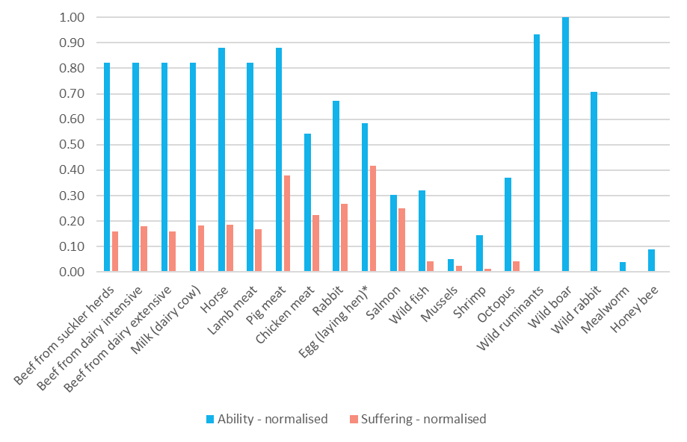
Animal scientists and veterinarians ranked wild boar to have the highest ability to perceive negative effects of being used by humans, followed by wild ruminants. For domestic animals, cattle, horses and pigs were ranked as having the highest ability, while mussels and mealworms were judged to have a considerably lower ability (Fig. 1).
Fig. 1. Ability to perceive negative effects of being used by humans for different animal species (blue) and suffering per animal (Danish production) (red) for production animals (above) and parent animals (below). Suffering normalised against a ‘dystopia’ scenario.

As for suffering per animal, hens had the highest score due to high disease prevalence; an average of 44% of hens suffer from keel bone fractures at 68 weeks of age (Rufener & Makagon, 2020). Pigs also had one of the highest suffering scores due to high mortality and lack of space (Table 3). Wild animals, mealworms and honeybees had considerably lower human induced suffering stemming only from slaughtering.
Table 3. Mortality and disease rates, slaughtering time (in share of 24h) and space as…Danish production
 | Mortality | Disease | Slaughter | Space
Production animals:
Cattle suckler herds | 0.0 | 0.05 | 0.25 | 0.24
Meat cattle dairy intensive | 0.07 | 0.10 | 0.25 | 0.10
Meat cattle dairy extensive | 0.08 | 0.05 | 0.25 | 0.12
Dairy cows | 0.06 | 0.10 | 0.25 | 0.14
Horse | 0.03 | 0.15 | 0.25 | 0.09
Lamb | 0.08 | 0.06 | 0.25 | 0.12
Pig | 0.23 | 0.15 | 0.25 | 0.63
Chicken | 0.04 | 0.12 | 0.17 | 0.62
Rabbit | 0.15 | 0.11 | 0.25 | 0.34
Laying hen | 0.04 | 0.46 | 0.25 | 0.42
Salmon | 0.16 | 0.15 | 0.25 | 0.03
Wild fish | 0 | 0 | 0.15 | 0
Mussels | 0 | 0 | 0.08 | 0
Shrimp | 0 | 0 | 0.04 | 0
Octopus | 0 | 0 | 0.15 | 0
Wild ruminants | 0 | 0 | 0.0007 | 0
Wild boar | 0 | 0 | 0.0007 | 0
Wild rabbit | 0 | 0 | 0.0007 | 0
Mealworm | 0 | 0 | 0.0007 | 0
Honey bee | 0 | 0 | 0.0003 | 0
Parent animals:

4.2 Animal welfare index per kg of animal product
Regardless of indicator used, meat from cattle and wild animals, mealworms and honey show low scores per kg of animal product (Fig. 2). For mealworms and honeybees this is partly an effect of our adjustment of ‘no of animals affected’ (section XX). Without this adjustment the score for mealworms and honeybees would have been….Meat from cattle show low scores due to their large body mass in comparison to other livestock species, resulting in a low ‘no of affected animals’ as one cattle animal give many kg of meat. Meat from wild animals show low per kg scores due to their low human induced ‘suffering’ (Table 3).
For PAALA chicken and rabbits have the highest scores due a high ‘no of animals affected’ as almost one animal is needed to produce one kg of meat (approximately 0.8 animals for chicken and 0.7 for rabbit; see SM1) and relatively high ‘suffering’ due to relatively high disease rates and lack of space (Fig. 2). When accounting for the time an animal lives before slaughter as in ALYS and PALYS, salmon scores worst of all species, due to is relatively long life duration (15 months compared to 5 weeks for chicken; see SM1). For the same reason eggs have higher scores relative other products when measured with ALYS or PALYS compared to PAALA (Fig. 2).
Adjusting for animals ‘ability to perceive negative effects of being used by humans’ in PALYS compared to ALYS did not change the ranking between products but made the difference between salmon, and chicken, rabbit and egg less pronounced as salmon was judged having a lower such ability (Fig. 1).

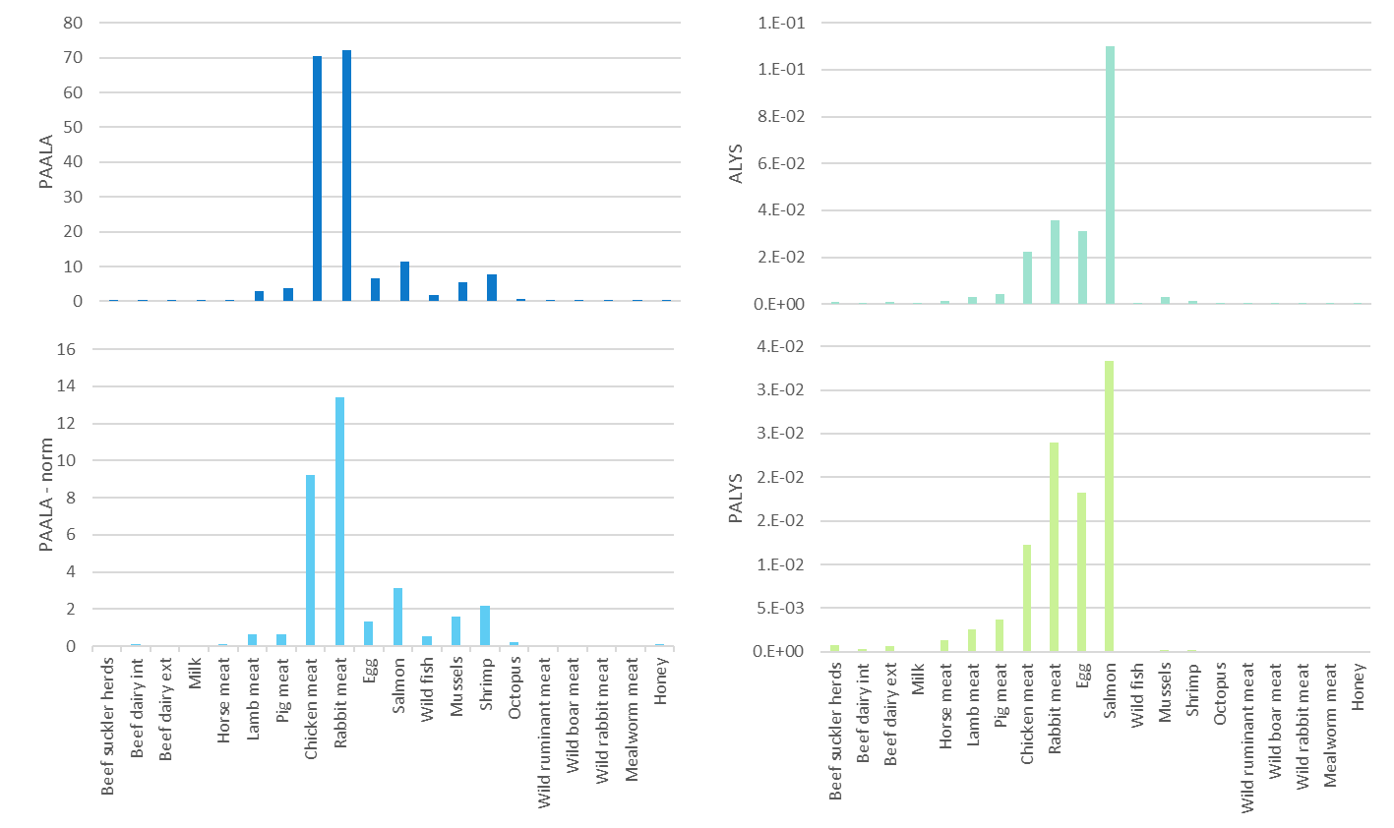
Fig. 2. Ability to perceive negative effects of being used by humans for different animal species (blue) and suffering per animal (Danish production) (red) for production animals (above) and parent animals (below). Suffering normalised against a ‘dystopia’ scenario.

4.3 Country differences for animal welfare
Variations in PAALA and PALYS between countries (Fig. 3) stem mainly from differences in ‘suffering’ reflecting varying mortality and disease prevalence and variations in space. Variation in egg scores depend on varying space allowances between countries with Hungary, Poland and Spain offering the least space for laying hens due to a large share of hens kept in cages while France, Germany and Sweden keep more than 90% of the laying hens in free-range systems (SchukPaim et al., 2021; SM1). For PALYS differences in ‘suffering’ between counties leads to more pronounced differences between counties in the overall score as ‘suffering’ is multiplied by the life duration which is relatively long for laying hens.
The low value for Swedish chicken also stems from larger space allowances for chicken in Sweden compared to other countries and lower disease prevalence (see SM1). Lamb from New Zealand has the lowest score of all lamb as lambs are raised entirely on pasture (giving maximum score for space) (Fig. 3). This is despite lamb production from New Zealand having a higher mortality rate then European lamb production (see SM1).

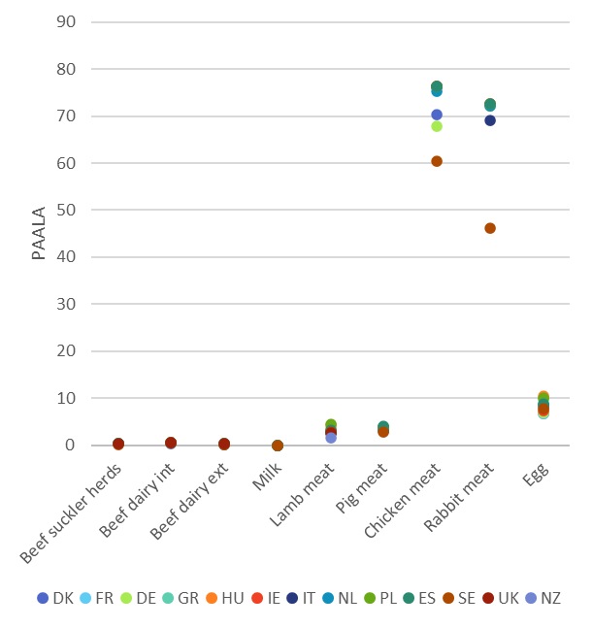 | 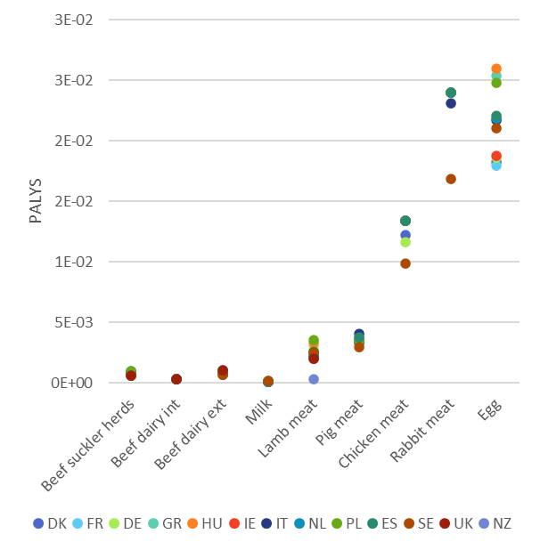
Fig. 3. PAALA and PALYS for livestock products produced in different countries.
Patterns in between country variation are similar for PAALA and PALYS (Table 4). Pig meat from Italy however presents an interesting exception. With PAALA, Italian (and Swedish) pig meat has the lowest score, i.e. has the lowest impact, while with PALYS, which also considers the life duration before slaughter, Italian pig meat score the worst of all pig meat. This is because Italian pigs are raised to a higher age (nine instead of six months) and when animal welfare loss is measured with PALYS living longer means that suffering is extended during a longer period and the score is higher.

Table 4. PAALA and PALYS for livestock products produced in different countries.
Perception Adjusted Animal Lifes Affected (PAALA)
 |  | DK |  | FR |  | DE | GR | HU | IE | IT | NL | PL | ES | SE | UK | NZ
Beef suckler herds |  | 0.28 |  | 0.26 |  | 0.30 | 0.30 | 0.32 | 0.27 | 0.36 | 0.27 | 0.35 | 0.24 | 0.22 | 0.25
Beef dairy int |  | 0.39 |  | 0.50 |  | 0.45 | 0.50 | 0.50 | 0.50 | 0.50 | 0.45 | 0.50 | 0.50 | 0.45 | 0.47
Beef dairy ext |  | 0.20 |  | 0.25 |  | 0.28 | 0.29 | 0.30 | 0.25 | 0.34 | 0.25 | 0.32 | 0.23 | 0.21 | 0.23
Milk |  | 0.01 |  | 0.01 |  | 0.01 | 0.01 | 0.01 | 0.01 | 0.01 | 0.01 | 0.01 | 0.01 | 0.01
Horse meat |  | 0.35 |  | 0.42 |  | 0.36 | 0.42 | 0.44 | 0.44 | 0.44 | 0.37 | 0.49 | 0.42 | 0.35
Lamb meat |  | 3.01 |  | 3.29 |  | 3.48 | 2.85 | 4.25 | 2.67 | 2.87 | 2.52 | 4.49 | 3.32 | 2.85 | 2.64 | 1.51
Pig meat |  | 3.76 |  | 3.85 |  | 3.66 | 3.78 | 3.66 | 3.65 | 2.93 | 3.52 | 3.78 | 3.98 | 2.89
Chicken meat |  | 70.3 |  | 76.4 |  | 67.9 | 76.4 | 76.4 | 76.4 | 76.4 | 75.3 | 76.4 | 76.4 | 60.4
Rabbit meat |  | 72.1 |  | 72.7 |  | 72.1 | 72.7 | 72.7 | 72.7 | 69.1 | 72.1 | 72.7 | 72.7 | 46.1
Egg |  | 6.71 |  | 6.81 |  | 6.90 | 9.93 | 10.4 | 7.35 | 8.51 | 8.14 | 10.0 | 8.85 | 7.71
Perception Adjusted Life Years Spent (PALYS)
 | DK |  | FR |  | DE |  | GR | HU | IE | IT | NL | PL | ES | SE | UK | NZ
Beef suckler herds | 8.1E-04 |  | 6.6E-04 |  | 8.6E-04 |  | 7.9E-04 | 8.4E-04 | 6.7E-04 | 9.8E-04 | 7.6E-04 | 9.3E-04 | 5.9E-04 | 6.2E-04 | 6.1E-04
Beef dairy int | 2.7E-04 |  | 3.1E-04 |  | 3.1E-04 |  | 3.1E-04 | 3.1E-04 | 3.1E-04 | 3.1E-04 | 3.1E-04 | 3.1E-04 | 3.1E-04 | 3.1E-04 | 2.9E-04
Beef dairy ext | 6.7E-04 |  | 7.4E-04 |  | 9.4E-04 |  | 8.7E-04 | 9.2E-04 | 7.5E-04 | 1.1E-03 | 8.4E-04 | 1.0E-03 | 6.7E-04 | 7.0E-04 | 1.0E-03
Milk | 9.1E-05 |  | 8.0E-05 |  | 7.8E-05 |  | 1.1E-04 | 9.2E-05 | 1.0E-04 | 1.1E-04 | 8.6E-05 | 1.2E-04 | 1.3E-04 | 1.3E-04
Horse meat | 1.3E-03 |  | 1.3E-03 |  | 1.4E-03 |  | 1.3E-03 | 1.3E-03 | 1.3E-03 | 1.3E-03 | 1.4E-03 | 1.5E-03 | 1.3E-03 | 1.3E-03
Lamb meat | 2.6E-03 |  | 2.5E-03 |  | 3.0E-03 |  | 2.2E-03 | 3.3E-03 | 2.0E-03 | 2.2E-03 | 2.2E-03 | 3.5E-03 | 2.6E-03 | 2.5E-03 | 2.0E-03 | 3.2E-04
Pig meat | 3.7E-03 |  | 3.6E-03 |  | 3.6E-03 |  | 3.5E-03 | 3.3E-03 | 3.3E-03 | 4.1E-03 | 3.4E-03 | 3.5E-03 | 3.8E-03 | 2.9E-03
Chicken meat | 1.2E-02 |  | 1.3E-02 |  | 1.2E-02 |  | 1.3E-02 | 1.3E-02 | 1.3E-02 | 1.3E-02 | 1.3E-02 | 1.3E-02 | 1.3E-02 | 9.9E-03
Rabbit meat | 2.4E-02 |  | 2.4E-02 |  | 2.4E-02 |  | 2.4E-02 | 2.4E-02 | 2.4E-02 | 2.3E-02 | 2.4E-02 | 2.4E-02 | 2.4E-02 | 1.7E-02
Egg | 1.8E-02 |  | 1.8E-02 |  | 1.9E-02 |  | 2.5E-02 | 2.6E-02 | 1.9E-02 | 2.2E-02 | 2.2E-02 | 2.5E-02 | 2.2E-02 | 2.1E-02

4.4 Use of antibiotics index per kg of animal product
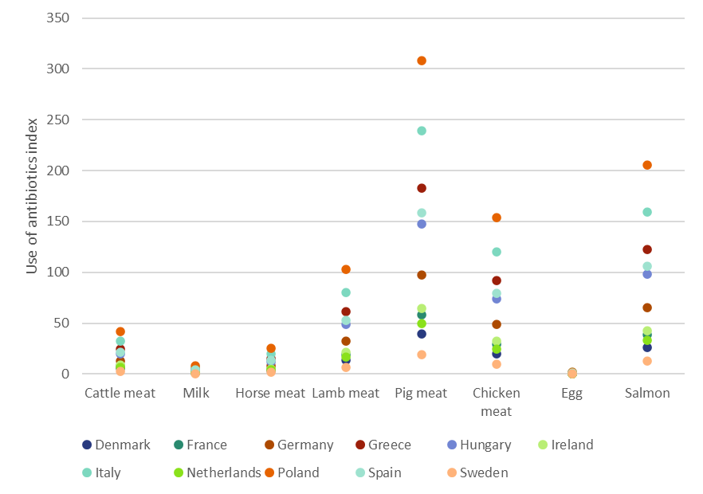
XXXX
Fig. 4. XXXX
Norway, Sweden and Denmark use less antibiotics than they would if their use were in accordance with the standard use calculated for different species (Table X). UK and the Netherlands use approximately the same amount as if their use were in accordance with the standard values. All other countries use more antibiotics than they would if their use were in accordance with the standard values, and this is especially evident for Italy and Poland.

4.5 Diet assessment
Irish consumption of animal products contributes substantially more to greenhouse gas emissions than Italian, and especially, Polish consumption (Fig. 5) due to high consumption of ruminant meat (Table 2). However, animal welfare loss from the diet is many driven by poultry consumption why Polish consumption shows the highest value for this index, followed by Irish consumption which also contains relatively high amounts of poultry. However, for use of antibiotics, Irish consumption has a substantially lower value than the Italian and Polish consumption. The high value for Polish consumption is a result of high consumption of pork and poultry and high use of antibiotics in Polish pig and poultry production (Fig. 4).
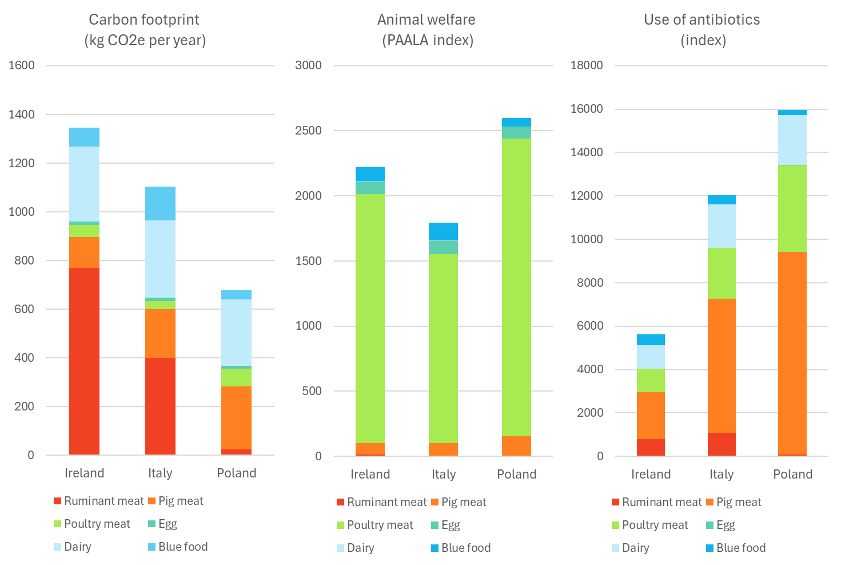
Fig. 5. Carbon footprint, animal welfare loss (PAALA) and use of antibiotics indices for consumption of animal products in the average Irish, Italian and Polish diet.
Replacing beef by rabbit in the Italian diet, might be seen as a possible option to mitigate emissions of greenhouse gases associated with the Italian diet, as rabbit has substantially lower carbon footprint than beef and is a culturally accepted commodity in Italy (ref). However, such a switch would result in higher animal welfare loss (Fig. 6) primarily due to a much larger number of animals being affected to produce the meat and higher suffering in rabbit than in beef production (Fig. 1). The use of antibiotics index would also more than double as use of antibiotics in rabbit production is exceptionally high (ref). Hence, for a replacement of beef by rabbit to be a sustainable option, animal welfare in rabbit production needs to be improved and use of antibiotics substantially reduced.
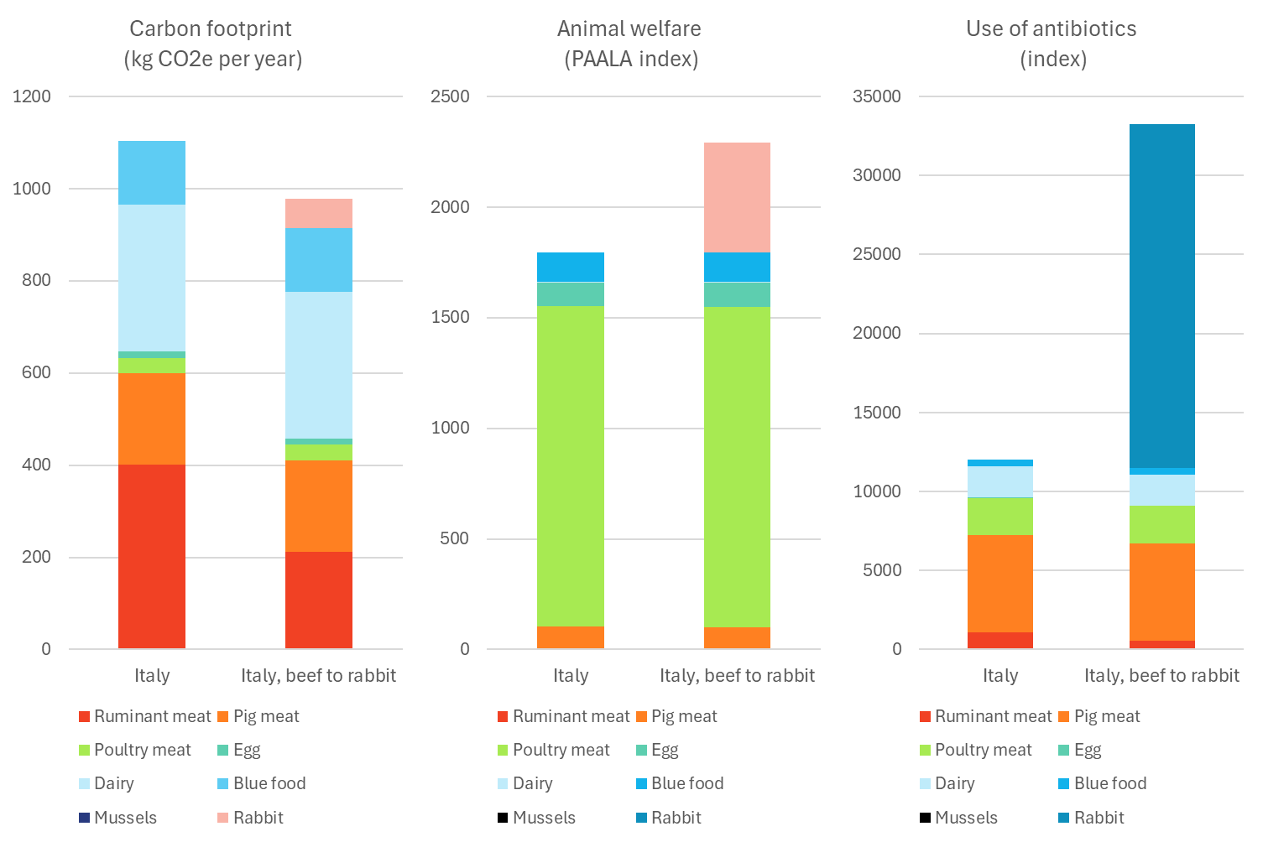
Fig. 6. Carbon footprint, animal welfare loss (PAALA) and use of antibiotics indices Italian baseline consumption and in a scenario in which 50% of beef is replaced by rabbit.
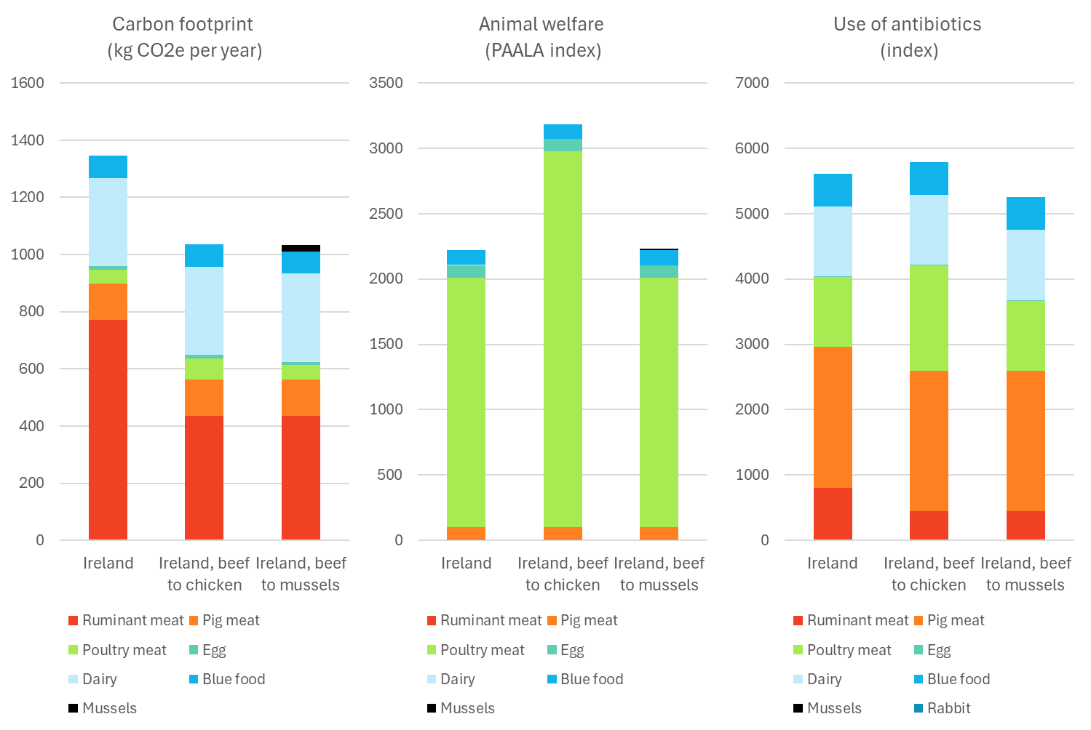
Turning to the Irish diet, replacing 50% of beef with either chicken or mussels, decreases the carbon footprint to the same extent (a 23% decrease) but with an increase in chicken consumption the animal welfare loss increases substantially. The use of antibiotics index also increases slightly with chicken, while it is slightly reduced by replacing beef by mussels (Fig. 7).

Fig. 7. Carbon footprint, animal welfare loss (PAALA) and use of antibiotics indices Irish baseline consumption and in one scenario in which 50% of beef is replaced by chicken and one in which 50% of beef is replaced by mussels.

5. Discussion
- Scherer et al uses the spline functions from Welfare Quality to reflect the non-linearity for Life Quality aspects (e.g. access to pasture). However, such spline functions were only available for a few aspect for some species (e.g. access to pasture for cattle, space for pigs and poultry) why we choose to calculate the Life Quality scores in the same way for all species.
- Rabbit and pigs that have high litter sizes also has high mortality rates -> bias using mortality as an indicator??
- PAALA – slakten får större vikt jämf med ALYS
- We only included negative animal welfare aspects…Svårt att mäta positive välfärd…
- Compare countries with care as scarce data om eg mortality and disease rates
- An indicator in which shorter life time is preferable (ALYS) might drive towards intensification, although captured by suffering, might not capture all aspects

- Konstigt med vilka djur ALYS, för det är väl rrimligen bättre att de vilda djuren lever längre? Talar för vårt index PAALA
- In addition to the human health aspect of using antibiotics to farm animals, there are ethical aspects related to goal conflicts between wellbeing of our and future generations, and between health risks for humans and suffering of sick animals (that could be cured by antibiotics). Sustainability assessments inherently include normative and ethical elements including what aspects to include in the assessment and how outcomes in different domains should be weighted, e.g. whether animal welfare and climate impact is equally important or not (ref).
- Vår metod inte bra för föräldradjuren, de syns inte…det här ska inte användas som ett verktyg för att prioritera insatser i produktionen, trösklar för vad som går av oberoende av hur många individer som drabbas och hur liten påverkan de har
- Inte obegränsat med vilt så inget alternativ att byta allt mot det
- Finns lusmedelresistens och annat också, cocciostatika…indikatorn beror människans hälsa snarare än produktionssystemets resiliens
- Saker som inte fångas: slaktmetoder (fisk, gris, nöt), svanskupering och liknande men fixering kommer med i space…
- Transporttiden vi använt för slakt inkluderar annan transport av levande djur (finns ej bättre data), men fångar iofs att man in vissa länder har mycket djurtransporter
- Risks with circular referencing antibiotics…
- Antibiotika saknas för Nord- och Sydamerika. Antibiotika kommer bli bättre för Europa (djurslagsvis). Only 2-5 countries contribute with information about how ‘easy’ or ‘difficult’ it is to maintain a low use of antibiotics for specific species (5 countries for cattle, pigs and poultry; 3 for sheep and goat, 2 for fish, rabbits and horses). The standardised values would have been much lower if data from Norway or Sweden were included and much higher if data from e.g. Cyprus or Poland were included. For European countries, the available data will become more detailed. According to the Delegated Regulation 2021/578 (EC, 2021) reporting of usage data for beef cattle, dairy cattle, pigs, chickens (with broiler chickens and laying hens being reported separately) and turkeys shall begin 2024, and reporting of usage in sheep, goats, fish, rabbits and horses shall begin 2027. Diskutera skillnaden i resultat vid användning av vår indikator och ”simpler indicator”.
- How this differs across production systems, e.g. organic… Hebink (2021) suggests share of certified organic products as an indicator. Welfare is often better in organic production systems (REF), but for example leg problems are more common in organic than conventional pig production (REF). Furthermore, data on proportion organic are lacking for imported animal-sourced food.
- Space mainly based on animal welfare law. Law compliance could also have been taken into account. Are there still pregnant sows housed in stalls in some European countries? Has been forbidden since 20xx.
- Fiskar i foder ej med
- Konsumtion av mindre animalier alltid ger lägre värden med våra indikatorer. Men vegetabiliers "harm" för djurlivet (t ex skogsskövling, pesticider) också borde räknas in i en bred kost-utvärdering (Harrison et al, 2022). Yes, but this would also raise values for animal products as they eat most of the plants, so it would increase the values of all products, and presumably increase the difference in animal suffering between plant-based products and animal products even more.
- Får och getmjölk ej med. Ren (som ligger mellan nöt och älg-hjort-rådjur) saknas. Kalkon saknas (ligger högt i antibiotika i US Bulut et al-22). Gås saknas (gåslever: tvångsmatning skulle inte fångas av index men leder till hög dödlighet [och antibiotikaanvändning], tror jag).
- Idén om att först definiera en accepterbar nivå och sen titta på % av inblandade djur – kan det funka?
- Meat consumption in Poland: https://www.mdpi.com/2304-8158/11/20/3283
“In each animal species, antibiotic use should be kept below 30 mg/PCU. Eventually, use should be cut to 15 mg/kg or less” https://epha.org/wp-content/uploads/2022/02/report-ending-routine-farm-antibiotic-use-in-europe-final-2022.pdf each species.
General evaluation based on national data are not valid for specific products. A fast food company may, for example, have high requirements on housing, management and slaughter process which improves animal welfare for the involved animals regardless of which country they are raised in. An animal welfare index like the one we present here could make it difficult for farmers with high animal welfare ambitions to sell their products to such a company if their farms are located in a country with low animal welfare in general.

6. Conclusions

Declaration of interests
The authors have no competing interests to declare.

Acknowledgements
Funding for this study come from Mistra Food Futures (DIA 2018/24 #8), a research program funded by Mistra (The Swedish Foundation for Strategic Environmental Research) and Plan’eat a XXXXXXXX. All funding is gratefully acknowledged. Our thanks also to all experts who answered the questionnaire and participated in the workshop.

CRediT authorship contribution statement
Lotta Rydhmer: Conceptualization, Methodology, Investigation, Formal analysis, Writing – original draft. Elin Röös: Conceptualization, Methodology, Writing – review & editing, Funding acquisition.

References:
Bartlett, H., Zanella, M., Kaori, B. et al. (2024) Trade-offs in the externalities of pig production are not inevitable. Nature Food 5, 312–322. https://doi.org/10.1038/s43016-024-00921-2
Hampton, J.O., Hyndman, T.H., Allen, B.L., Fischer, B. (2021) Animal Harms and Food Production: Informing Ethical Choices. Animals (Basel) 11(5):1225. https://doi.org/10.3390/ani11051225
Keeling, L. 2005. Healthy and Happy: Animal Welfare as an Integral Part of Sustainable Agriculture. AMBIO: A Journal of the Human Environment 34(4), 316-319. https://doi.org/10.1579/0044-7447-34.4.316
Paris, J., Falkenberg, T., Nöthlings, U., et al. (2022). Changing dietary patterns is necessary to improve the sustainability of Western diets from a One Health perspective. Science of The Total Environment 811:151437. https://doi.org/10.1016/j.scitotenv.2021.151437
Regan, T. (1985) The case for animal rights. University of California Press, Oakland.
Scherer, L., Tomasik, B., Rueda, O. et al. (2018) Framework for integrating animal welfare into life cycle sustainability assessment. International Journal of Life Cycle Assessment 23, 1476–1490. https://doi.org/10.1007/s11367-017-1420-x
Schwarzmueller, F. & Kastner, T. (2022). Agricultural trade and its impacts on cropland use and the global loss of species habitat. Sustainability Science 17 (6), 2363–2377. https://doi.org/10.1007/s11625-022-01138-7
Singer, P. (1975). Animal Liberation: A New Ethics for our Treatment of Animals. New York: New York Review/Random House
Springman, M., Spajic, L., Clark, M., et al. (2020) The healthiness and sustainability of national and global food based dietary guidelines: modelling study. BMJ 370:m2322. https://doi.org/10.1136/bmj.m2322
Vinnari, E., Vinnari, M. (2022) Making the invisibles visible: Including animals in sustainability (and) accounting. Critical Perspectives on Accounting 82:102324. https://doi.org/10.1016/j.cpa.2021.102324
Zira, S., Rydhmer, L., Ivarsson, E., Hoffmann, R., Röös, E. (2021). A life cycle sustainability assessment of organic and conventional pork supply chains in Sweden. Sustainable Production and Consumption 28, 21-38. https://doi.org/10.1016/j.spc.2021.03.028
Referenser

AGES, 2023 Antibiotic sales volumes in veterinary medicinehttps://www.ages.at/en/animal/veterinary-medicines-hormones/antibiotic-sales-volumes-in-veterinary-medicine

Tallon RE, Whitt B, Bladon BM.Antibiotic usage in 14 equine practices over a 10-year period(2012–2021). Equine Vet J. 2023.https://doi.org/10.1111/evj.139888TALLONET AL.

NORM/NORM-VET 2021. Usage of Antimicrobial Agents and Occurrence of Antimicrobial
Resistance in Norway. Tromsø / Oslo 2022. ISSN:1502-2307 (print) / 1890-9965 (electronic).

Swedres svarm 2021 https://www.sva.se/media/8da965da486b11e/swedres_svarm_2021.pdf

Humphry RW, Henry MK, Reeves A, et al. Estimating antimicrobial usage based on sales to beef and dairy farms from UK veterinary practices. Vet Rec. 2021;e28. https://doi.org/10.1002/vetr.28

Shiels D, Loughrey J, Dwyer CM, Hanrahan K, Mee JF, Keady TWJ. 2022. A Survey of Farm Management Practices Relating to the Risk Factors, Prevalence, and Causes of Lamb Mortality in Ireland. Animals 12(1):30. https://doi.org/10.3390/ani12010030

Bruce et al, 2021. M. Bruce, J.M. Young, D.G. Masters, G. Refshauge, A.N. Thompson, P.R. Kenyon, R. Behrendt, A. Lockwood, D.W. Miller, C. Jacobson. 2021. The impact of lamb and ewe mortality associated with dystocia on Australian and New Zealand sheep farms: a systematic review, meta-analysis and bio-economic model. Prev. Vet. Med., 196 (2021), Article 105478, 10.1016/j.prevetmed.2021.105478

https://www.legislation.gov.uk/uksi/2007/2078/schedule/6/made

Beeflambnz, 2019. www.beeflambnz.com Beef + Lamb New Zealand,

Danska djurskyddslagen

Sandöe 2023

Fiskeri- og kystdepartementet, 2008. Forskrift om drift av akvakulturanlegg. https://lovdata.no/dokument/SF/forskrift/2008-06-17-822

Baxter EM, Moustsen VA, Goumon S, Illmann G and Edwards SA (2022) Transitioning from crates to free farrowing: A roadmap to navigate key decisions. Front. Vet. Sci. 9:998192. doi:10.3389/fvets.2022.998192

BUIL T., MARÍA G.A., VILLARROEL M., LISTE G., LÓPEZ M. 2004. CRITICAL POINTS IN THE TRANSPORT OF COMMERCIAL RABBITS TO SLAUGHTER IN SPAIN THAT COULD COMPROMISE ANIMALS’ WELFARE. World Rabbit Sci. 12, 269 – 279. https://doi.org/10.1016/j.livsci.2018.02.005

Claudia Cauccia,⁎, Guido Di Martinoa, Katia Capelloa, Matteo Mazzucatoa, Angela Trocinob,
Gerolamo Xiccatoc, Nadia Lagod, Michele Brichesee, Lebana Bonfantia. 2018. Risk factors for pre-slaughter mortality in fattening and breeding rabbits

CRF, 2023 (gödsel på bete från klimatrapportering)

Danish Veterinary and Food Administration, 2020. Order on minimum animal welfare requirements for the keeping of cattle. Bekendtgørelsenr.1743af30/ 11/2020. https://www.retsinformation.dk/eli/lta/2020/1743

De Jong, IC, Guémené, D. 2011. Major welfare issues in broiler breeders. World's Poultry Science Journal 67, 73-82. DOI: 10.1017/S0043933911000067

DG SANTE, 2017. Overview report of the Directorate General for health and food safety on commercial rabbit farming in the European Union. doi:10.2772/898828

OVERVIEW REPORT OF THE DIRECTORATE-GENERAL FOR HEALTH AND FOOD SAFETY ON COMMERCIAL FARMING OF RABBITS IN THE EUROPEAN UNION

ECA. 2023. Transport of live animals in the EU: challenges and opportunities. Review 03. European Court of Auditors. https://www.europarl.europa.eu/news/en/press-room/20220114IPR21025/animals-must-be-better-protected-during-transport

EFSA, 2005. The Impact of the current housing and husbandry systems on the health and welfare of farmed domestic rabbits. Scientific Opinion of the Scientific Panel on Animal Health and Welfare. EFSA Journal 267, 1-31.

EFSA, 2020. Health and welfare of rabbits farmed in different production systems. Scientific opinion from EFSA Panel on Animal Health and Animal Welfare. EFSA Journal 18, 5944. https://doi.org/10.2903/j.efsa.2020.5944

EFSA, 2023a. Scientific opinion on the welfare of dairy cows. EFSA Panel on Animal Health and Animal Welfare. Scientific EFSA Journal 21, 7993 https://doi.org/10.2903/j.efsa.2023.7993

EFSA, 2023b. Scientific opinion on the welfare of laying hens on farm. EFSA Panel on Animal Health and Animal Welfare. EFSA Journal xxx. https://doi.org/10.2903/j.efsa.2023.7789

Erens J, Es Van S, Haverkort F, Kapsomenou E, & Luijben A (2012) “A bug’s life: large scale insect rearing in relation to animal welfare.”Wageningen University and Research.

EU 1999. Council Directive 1999/74/EC of 19 July 1999 laying down minimum standards for the protection of laying hens

EU 2007. Council Directive 2007/43/EC of … broilers

EU, 2008. Council Directive 2008/120/EC laying down minimum standards for the protection of pigs.

EU, 2008 b. Directive 2008/119/EC — minimum standards for the protection of calves

EU, 2020. COMMISSION IMPLEMENTING REGULATION (EU) 2020/464 of 26 March 2020 laying down certain rules for the application of Regulation (EU) 2018/848 of the European Parliament and of the Council as regards the documents needed for the retroactive recognition of periods for the purpose of conversion, the production of organic products and information to be provided by Member States https://eur-lex.europa.eu/legal-content/EN/TXT/PDF/?uri=CELEX:32020R0464&rid=4

Granquist, EG, G. Vasdal, G, de Jong, IC, Moe, RO 2019. Lameness and its relationship with health and production measures in broiler chickens Animal 13, 2365-2372 doi:10.1017/S1751731119000466

M Heinonen 1, J Oravainen, T Orro, L Seppä-Lassila, E Ala-Kurikka, J Virolainen, A Tast, O A T Peltoniemi. 2006. Lameness and fertility of sows and gilts in randomly selected loose-housed herds in Finland. Vet Rec 16, 383-387. DOI: 10.1136/vr.159.12.383

Ireland, JL, Wylie, CE, Collins, SN, Verheyen, KLP, Newton, JR. 2013. Preventive health care and owner-reported disease prevalence of horses and ponies in Great Britain. Research in Veterinary Science 95, 418–424

Jordbruksverket. 2012. Nötkreaturssektorns uppbyggnad. En analys av struktur och slakt i nötkreaturssektorn [Composition of cattle sector. An analysis of structure and slaughter in the cattle sector] https://jordbruksverket.se/om-jordbruksverket/jordbruksverkets-officiella-statistik/jordbruksverkets-statistikrapporter/statistik/2020-06-22-notkreaturssektorns-uppbyggnad.-en-analys-av-struktur-och-slakt-i-notkreaturssektorn Published 2012-08-28

Jordbruksverket. 2022. Nötkreaturssektorns uppbyggnad. En analys av struktur och slakt i nötkreaturssektorn [Composition of cattle sector. An analysis of structure and slaughter in the cattle sector] https://jordbruksverket.se/om-jordbruksverket/jordbruksverkets-officiella-statistik/jordbruksverkets-statistikrapporter/statistik/2022-02-01-notkreaturssektorns-uppbyggnad--en-analys-av-struktur-och-slakt-i-notkreaturssektorn. Published 2022-02-01

Jordbruksverket. 2023. Djurhälsa år 2022 [Animal health year 2022]. Report JO1302. https://jordbruksverket.se/om-jordbruksverket/jordbruksverkets-officiella-statistik/jordbruksverkets-statistikrapporter/statistik/2023-10-24-djurhalsa-ar-2022. Published 2023-10-24

Kaukonen et al 2017. Animal 11, 864–871 doi:10.1017/S1751731116002160

Mandel R, Bracke MBM, Nicol CJ, Webster JA, Gygax L. 2022. Dairy vs beef production - expert views on welfare of cattle in common food production systems. Animal 16:100622. doi: 10.1016/j.animal.2022.100622.

Minestero della salute, 2021. LINEE GUIDA DEL MINISTERO DELLA SALUTE PER L’ALLEVAMENTO DEL CONIGLIO. https://www.conaf.it/sites/default/files/Linee%20guida%20conigli.pdf

PHELAN P, MORGAN ER, ROSE H, GRANT J, O'KIELY P. 2016. Predictions of future grazing season length for European dairy, beef and sheep farms based on regression with bioclimatic variables. The Journal of Agricultural Science 154, 765-781. doi:10.1017/S0021859615000830

Schuck‑Paim, C, Negro‑Calduch, E, Alonso, WJ. 2021. Laying hen mortality in different indoor housing systems: a meta‑analysis of data from commercial farms in 16 countries. Scientific Reports 11, 3052. https://doi.org/10.1038/s41598-021-81868-3

SJV, 2017. Statens jordbruksverks föreskrifter och allmänna råd om kaninhållning inom lantbruket m.m. SJVS 2017:29 Saknr L 112

SJV, 2019a. Statens jordbruksverks föreskrifter och allmänna råd om fjäderfähållning inom lantbruket m.m. SJVFS 2019:23 Saknr L 111

SJV, 2019b. Statens jordbruksverks föreskrifter och allmänna råd om hästhållning. SJVFS 2019:17 Saknr L 101

SJV, 2019c. Statens jordbruksverks föreskrifter och allmänna råd om grishållning inom lantbruket m.m. SJVFS 2019:20 Saknr L 106

SJV, 2019d. Statens jordbruksverks föreskrifter och allmänna råd om fårhållning inom lantbruket m.m. SJVFS 2019:21 Saknr L 107

SJV 2019e. Statens jordbruksverks föreskrifter och allmänna råd om nötkreaturshållning inom lantbruket m.m.. SJVFS 2019:18 Saknr L 104

Svensson C, Lundborg K, Emanuelson U, Olsson SO. 2003. Morbidity in Swedish dairy calves from birth to 90 days of age and individual calf-level risk factors for infectious diseases. Prev Vet Med. 58, 179-97. doi: 10.1016/s0167-5877(03)00046-1.

TAPPREST, J, MORIGNAT, E, DORNIER, X, BOREY, M, HENDRIKx, P, FERRY, B, CALAVAS, D, SALA, C. 2017. Fallen stock data: An essential source of information forquantitative knowledge of equine mortality in France. Equine Veterinary Journal 49, 596-602. DOI: 10.1111/evj.12664

Teagasc, 2022. Sheep Housing: Space Requirements. https://www.teagasc.ie/news--events/daily/sheep/sheep-housing-space-requirements.php

The Better Chicken, nd. EU BROILER CHICKEN WELFARE. https://betterchickencommitment.com/eu-broiler-chicken-welfare.pdf

Thomson, S, Spencer, M, Reeves, A, Moxey, A. 2020. Structure and Efficiency of the Scottish Beef Herd - Cattle Tracing System Insights. Scotland's Rural College (SRUC).

Thøfner, ICN, Louise Ladefoged Poulsen, L, Bisgaard, M, Christensen, H. Heidemann Olsen, R, Christensen, JP. 2019. Longitudinal Study on Causes of Mortality in Danish Broiler Breeders. Avian diseases 63, 400–410. https://doi.org/10.1637/12006-113018-Reg.1

Thøfner, ICN, Dahl, J, Christensen, JP. 2021. Keel bone fractures in Danish laying hens: Prevalence and risk factors.PLoS ONE 16, e0256105. https://doi.org/10.1371/journal. pone.0256105

van der Eijk, JAJ, van Harn, J, Gunnink, H, Melis, S, van Riel, JW, de Jong, IC. 2023. Fast- and slower-growing broilers respond similarly to a reduction in stocking density with regard to gait, hock burn, skin lesions, cleanliness, and performance. Poultry Science 102, 102603. https://doi.org/10.1016/j.psj.2023.102603

Trocino A, Menegon F, Zomeño C, Pasqualin D, Cunial G, Xiccato G, Pirrone F, Bertotto D, Bortoletti M, Dorigo F, Lavazza A and Di Martino G. 2022. A pilot study about on-farm assessment of health and welfare in rabbits kept in different housing systems. Front. Vet. Sci. 9:936643. doi:10.3389/fvets.2022.936643

Växa 2023a. Växa Husdjursstatistik [Cattle statistics 2022]. https://vxa.qbank.se/mb/?h=c7a1d64e698d8df91094699ba3ffd110&p=dccda36951e6721097a93eae5c593859&display=feature&s=name&d=desc. Published 2023-06-13

Växa 2023b. Djurhälsostatistik 2020–2021. [Cattle health statistics 2020–2021]. https://vxa.qbank.se/mb/?h=3fb6d74d47ca02f4f86b10e5bc2e1465&p=dccda36951e6721097a93eae5c593859&display=feature&s=name&d=desc. Published 2023-03-30

Gård och djurhälsan, 2023. Genomsnittligt kvalitetsutfall för nötkreatur slaktade under 2022. https://www.gardochdjurhalsan.se/kvalitetsutfall-slaktade-notkreatur/

Van Limbergen, T, Sarrazin, S, Chantziaras, I, Dewulf, J, Ducatelle, R, … et al. 2020. Risk factors for poor health and performance in European broiler production systems. BMC Veterinary Research 16, 287. https://doi.org/10.1186/s12917-020-02484-3

ORIGINAL RESEARCH article
Front. Vet. Sci., 30 October 2017
Sec. Veterinary Epidemiology and Economics
Volume 4 - 2017 | https://doi.org/10.3389/fvets.2017.00181
This article is part of the Research Topic
Proceedings of the Inaugural ISESSAH Conference

View all 12 Articles
Modeling the Costs of Postpartum Dysgalactia Syndrome and Locomotory Disorders on Sow Productivity and Replacement
imageJarkko K. Niemi1* imagePaula Bergman2 imageSami Ovaska3 imageMarja-Liisa Sevón-Aimonen4 imageMari Heinonen5
AssureWel http://www.assurewel.org/sheep/mortality.html
Rydhmer et al 2021
by Pauline Kooh 1,Vanessa Jury 2,Sophie Laurent 2,Frédérique Audiat-Perrin 1,Moez Sanaa 1,Vincent Tesson 3ORCID,Michel Federighi 3ORCID andGéraldine Boué 3 210512.pdf
Control of Biological Hazards in Insect Processing: Application of HACCP Method for Yellow Mealworm (Tenebrio molitor) PowdersFoods 2020, 9(11), 1528; https://doi.org/10.3390/foods9111528
Transport of live animals in the EU: challenges and opportunities https://www.eca.europa.eu/Lists/ECADocuments/RV-2023-03/RV-2023-03_EN.pdf
Shiels, D.; Loughrey, J.; Dwyer, C.M.; Hanrahan, K.; Mee, J.F.; Keady, T.W.J. A Survey of Farm
Management Practices Relating to the Risk Factors, Prevalence, and Causes of Lamb Mortality in Ireland. Animals 2022, 12, 30. https://doi.org/10.3390/ani12010030

AHDB, 2021. Factors affecting neonatal survival. https://ahdb.org.uk/development-of-an-integrated-neonatal-survival-and-sustainable-antibiotic-plan

EweWastageinNewZealandCommercialFlocks:Extent, Timing,AssociationwithHoggetReproductiveOutcomes andBCS KateJ.Flay1,* ,AnneL.Ridler2,ChrisW.R.Compton2andPaulR.Kenyon3 Animals2021,11,779.https://doi.org/10.3390/ani11030779

Sustainablelambproduction:Evaluationof factorsaffectinglambgrowth usinghierarchical,crossclassifiedandmultiplemembershipsmodels Preventive Veterinary Medicine 174 (2020) 104822 https://doi.org/10.1016/j.prevetmed.2019.104822 Received8May2019;Receivedinrevisedform1November ElianaLimaa,*,FionaLovatta,MartinGreena,JanetRodenb,PeersDaviesa,1,2,JasmeetKaler

Lamb feedlot production in Spain : Most relevant health issues J.M. Gonzáleza, J.M. Bellob, M. Rodríguezc, T. Navarrod, D. Lacastad,∗, A. Fernándezd, M. De las Herasd Small Ruminant Research 142 (2016) 83–87 http://dx.doi.org/10.1016/j.smallrumres.2016.02.020

(Ellen Sofie Grefsrud, Lasse Berg Andersen, Bjørn Einar Grøsvik, Ørjan Karlsen, Bjørn Olav Kvamme, Pia Kupka Hansen, Vivian Husa, Nina Sandlund, Lars Helge Stien og Monica F. Solberg 2023. Risikorapport norsk fiskeoppdrett 2023 - Produksjonsdødelighet hos oppdrettsfisk og miljøeffekter av norsk fiskeoppdrettRapport fra havforskningen 2023-6.)

Sommerset I, Wiik-Nielsen J, Oliveira VHS, Moldal T, Bornø G, Haukaas A og Brun E.
Fiskehelserapporten 2022, Veterinærinstituttets rapportserie nr. 5a/2023, utgitt av
Veterinærinstituttet 2023

European Council, 2022. Updating legislation on the transport of animals in the EU - Information from the Belgian, Danish, Dutch, German and Swedish delegations. Note 11061/22 from General Secretariat of the Council. https://data.consilium.europa.eu/doc/document/ST-11061-2022-INIT/en/pdf

Inte använt: https://food.ec.europa.eu/system/files/2017-11/aw_platform_res-lib_horses-guide.pdf

Nunan, C. 2022. Ending routine farm antibiotic use in Europe. Achieving
responsible farm antibiotic use through improving animal health and welfare in pig
and poultry production. European Public Health Alliance (EPHA).
REF ratio given to livestock
EU Commission, 2020
ESVAC 2022
EU Commission 2021. COMMISSION DELEGATED REGULATION (EU) 2021/578 of 29 January 2021 supplementing Regulation (EU) 2019/6 of the European Parliament and of the Council with regard to requirements for the collection of data on the volume of sales and on the use of antimicrobial medicinal products in animals, https://eur-lex.europa.eu/legal-content/EN/TXT/
PDF/?uri=CELEX:32021R0578&from=EN
UK-VARSS 2018, 2021

